KDM: ICP 11

Name :Anusha Yanamala

Student Id:16317767

Here I am discussing about CNN conversional neural network. So we are building CNN using keras library.

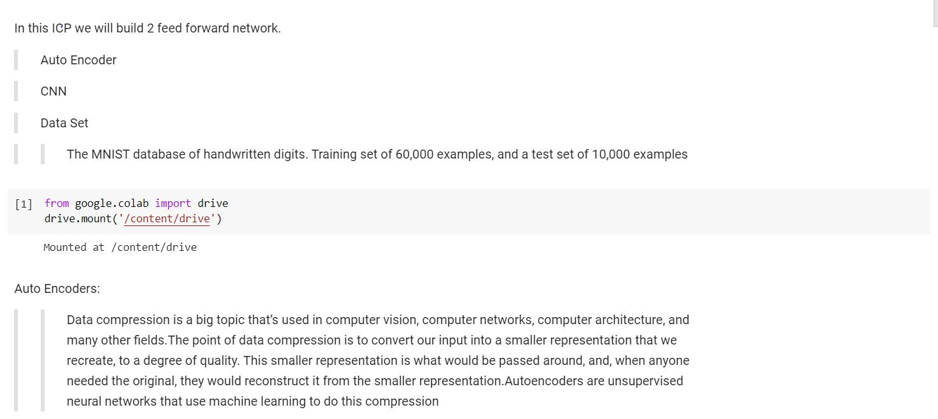

Here I imported all required libraries. I imported cifar10 dataset from keras.

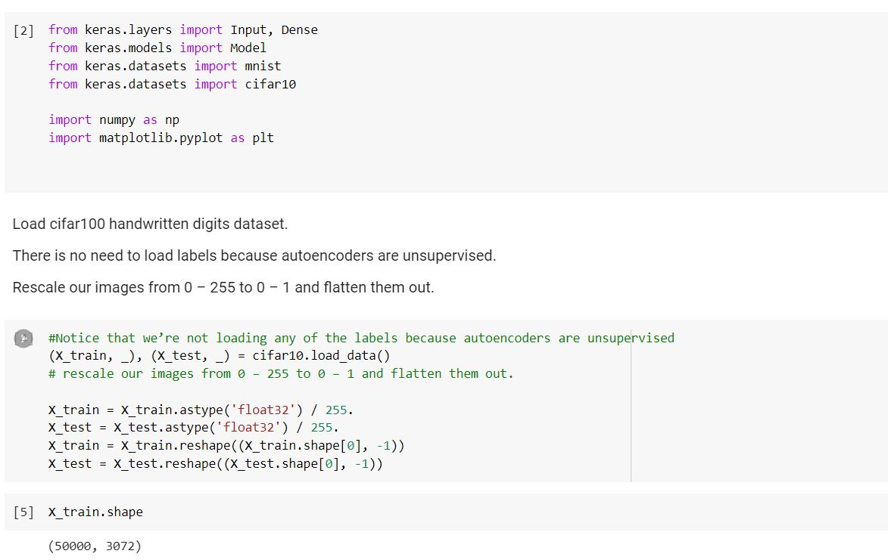

Here I added one layer. First we need to encode and then decode the layer.so to match the model I added one encoded layer.

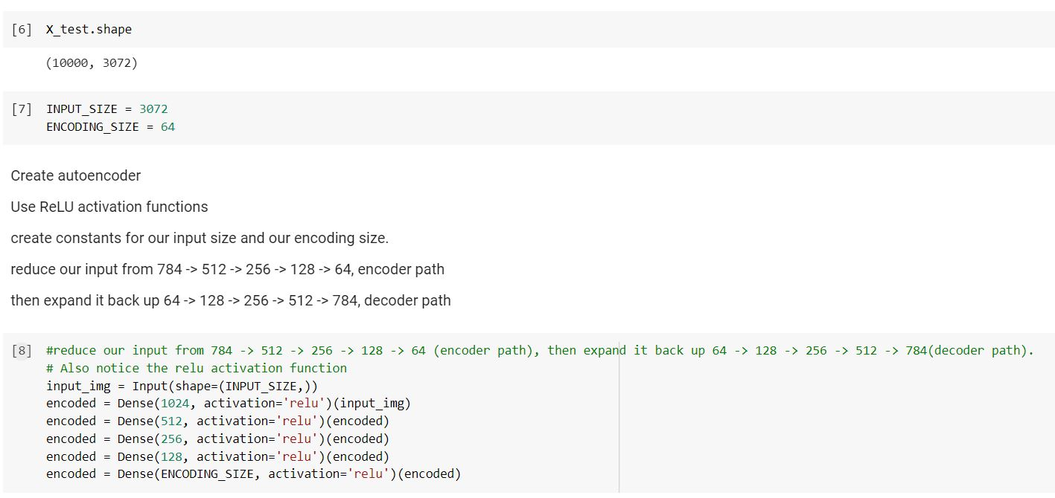

Added one decoded layer.

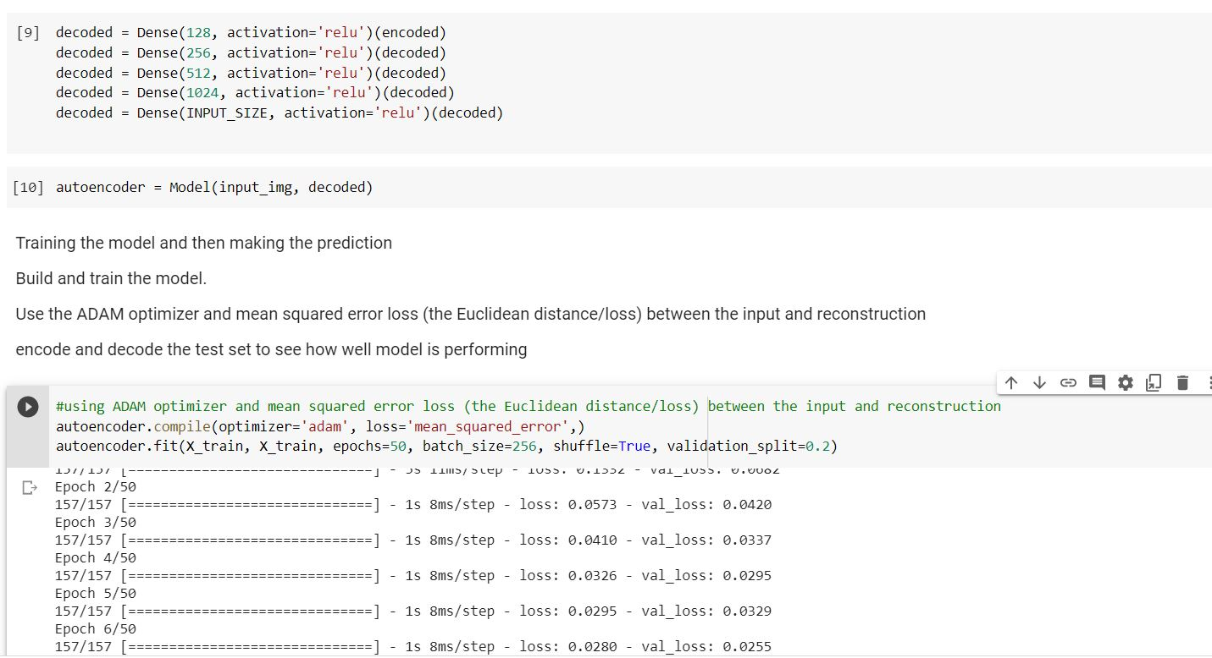

ADAM optimizer:

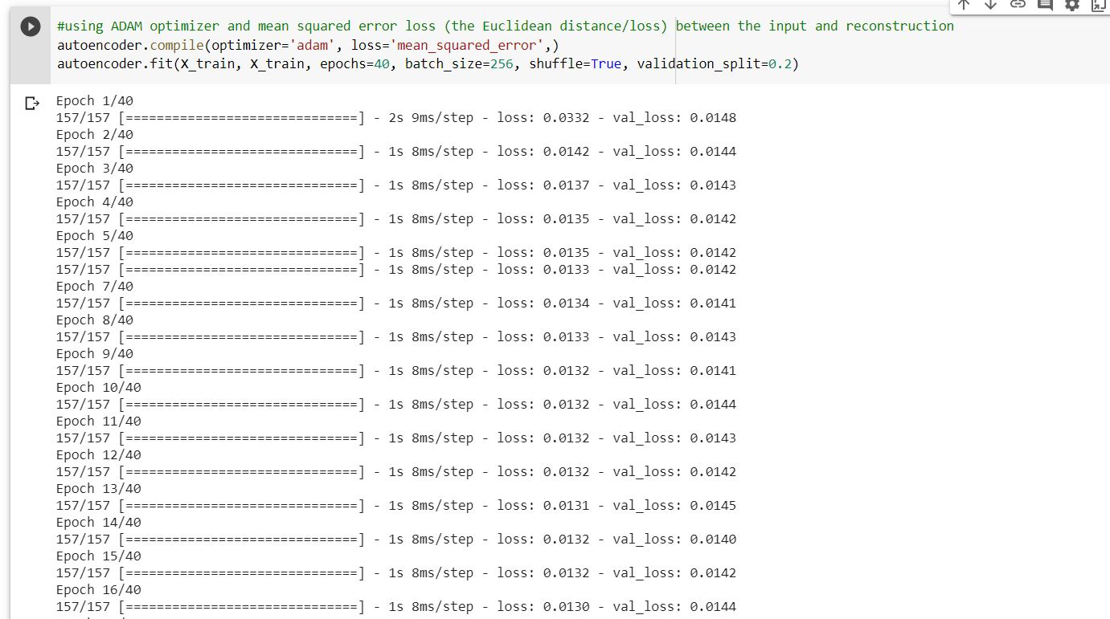

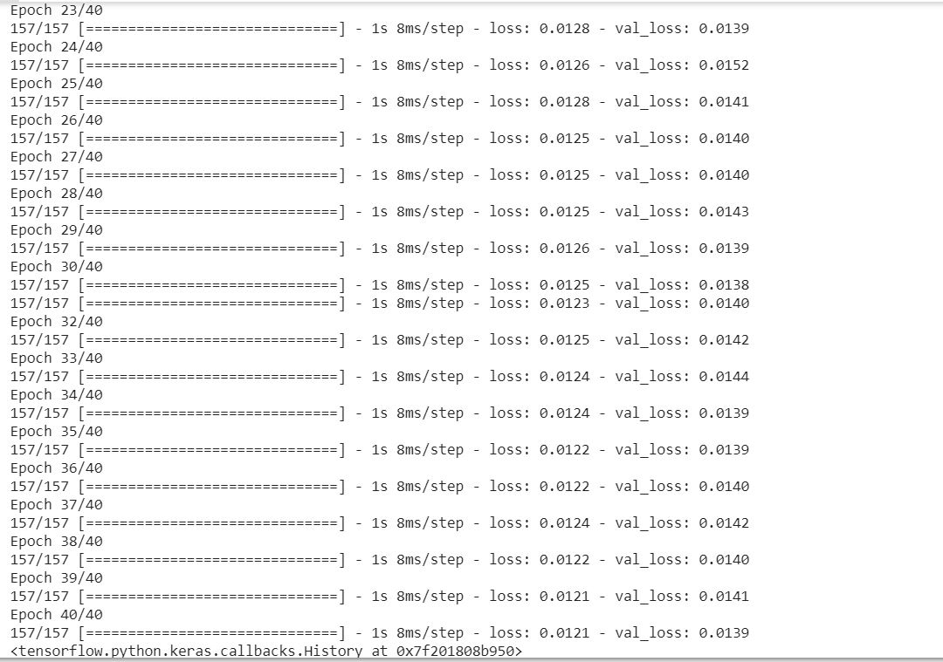

Here I have taken 15 images.

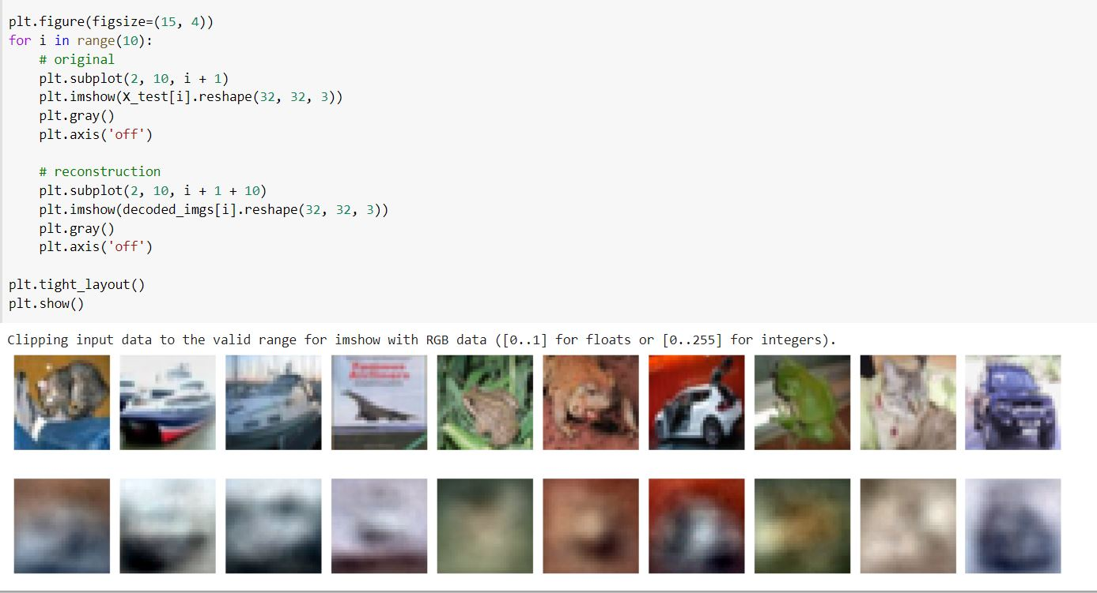

I imported cifer10 dataset.

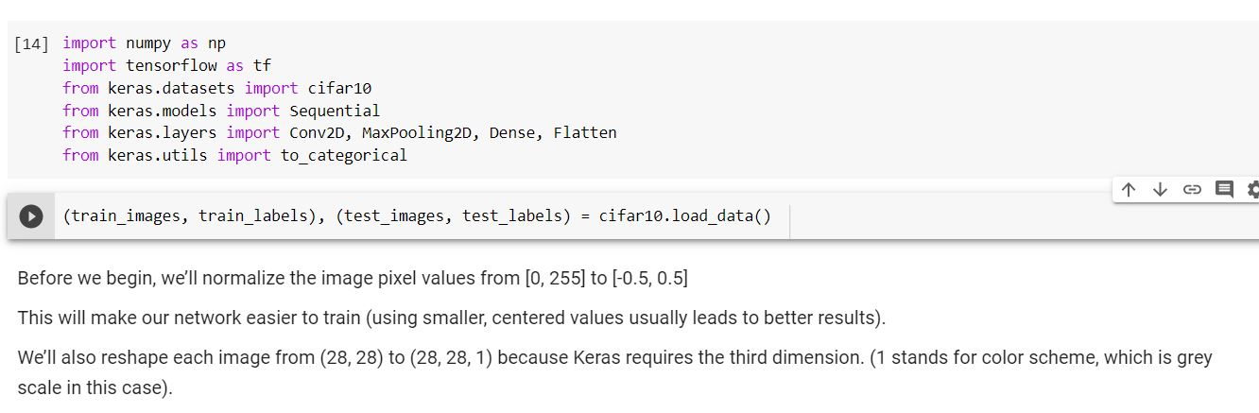

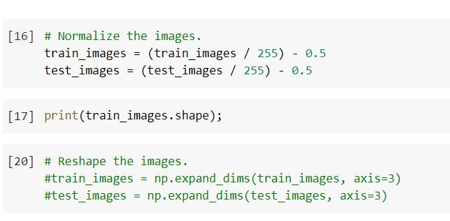

I changed the num_filters=10 ,filter_size=7 and pool_size=5.

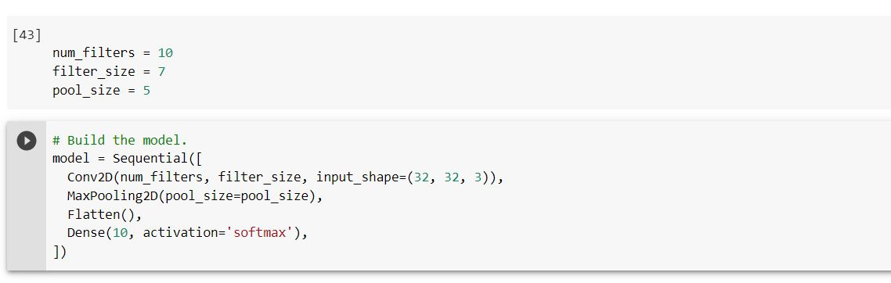

Here I compiled the model.

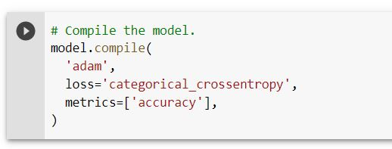

Training the model as shown below:

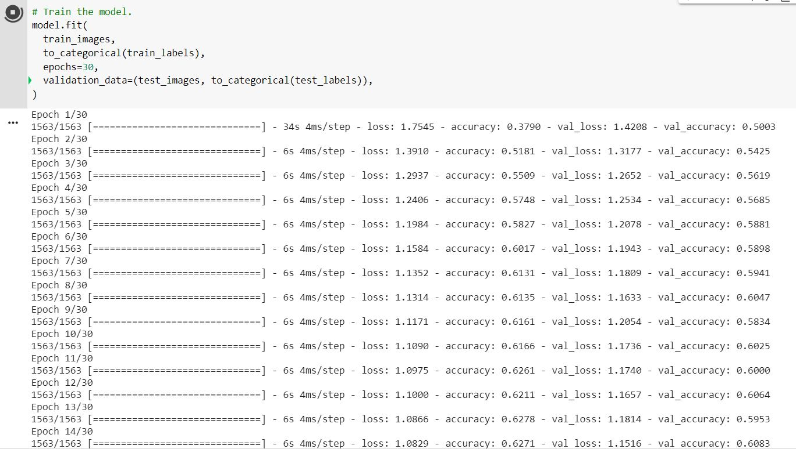

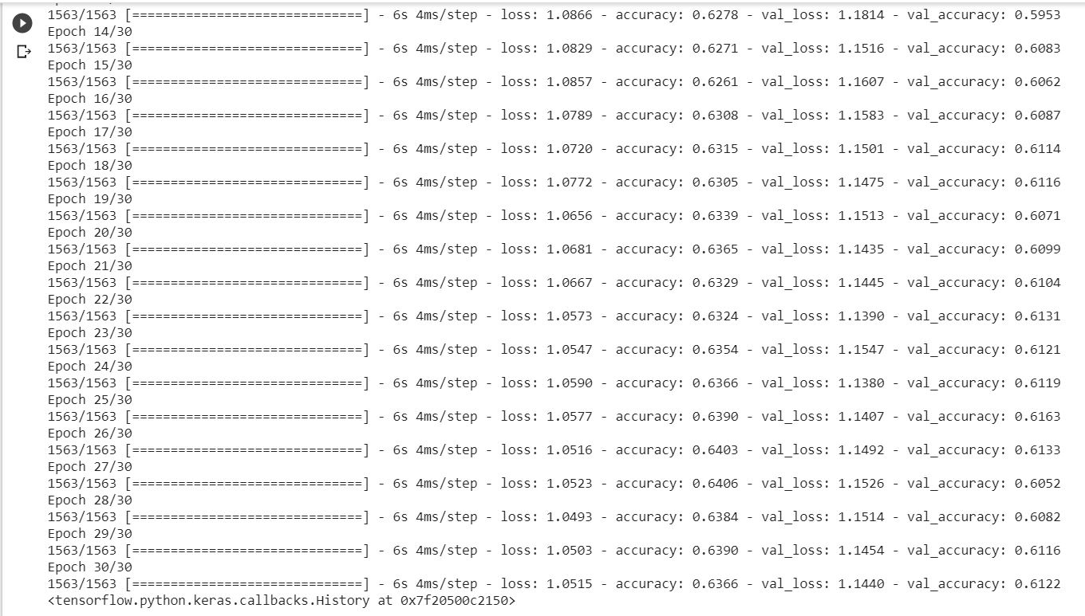

Predict on the first 20 test images.

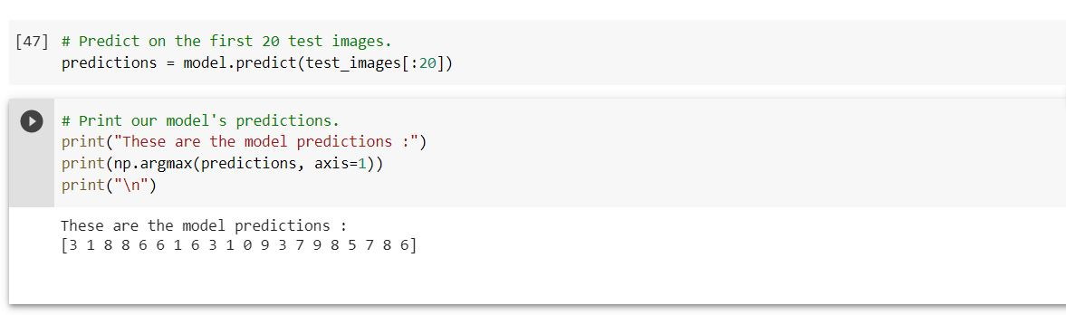

Prediction against the ground truths.

